Town Happiness Measure

A Command-Line Program to Efficiently Measure Your Town’s Happiness

Charlie Morrison - S3658449

Contents

2 Purpose 3

3 Classification 3

4 Usage 4

4.1 Loading Files 4

4.1.1 Step 1 4

4.1.2 Step 2 4

4.2 Adding Records 5

4.2.1 Step 1 5

4.2.2 Step 2 5

4.2.3 Step 3 5

4.3 Showing Records 6

4.3.1 Step 1 6

4.3.2 Step 2 6

4.4 Changing File 7

4.4.1 Step 1 7

4.4.2 Step 2 7

4.4.3 Step 3 7

4.5 Saving Records 8

4.5.1 Step 1 8

4.5.2 Step 2 8

4.6 8

4.7 Quitting 9

4.7.1 Step 1 9

# Purpose

The purpose of this program is in order to efficiently measure a town’s happiness, and the reason behind why certain personnel are happy. It orders the data by time of entry.

This dataset processing program uses the following data: First name, last name, whether the citizen is generally happy. And, for the following, the citizen scores their preference of whether it provides them with happiness: City services, cost of housing, quality of public schools, trust in local police, maintenance of the streets and sidewalks, availability of social community events.

This program is a database processor; therefore, it can store and retrieve data. The program saves the internal data as a csv, and can reload the data for use later on. The data is stored in the same format as the UCI database which inspired it.

The UCI database which inspired this works is the [Somerville Happiness Survey Data Set](https://archive.ics.uci.edu/ml/datasets/Somerville+Happiness+Survey).

# Classification

This program is classified as unclassified, upon first entry of data it is classified Personal: Privacy. This is due to the nature of associating a citizen’s name with their satisfaction. This program, while loaded, is not to be shared with any unauthorised personnel. Charlie Morrison does not take responsibility of unauthorised exposures or data leaks which may occur in case of inappropriate usage.

# Usage

## Loading Files

### Step 1

Once the program is first opened, it will immediately prompt you to input what file you would like to modify.



### Step 2

Once you have written down which file you would like the program to open, it will prompt a confirmation to ensure it does not incidentally open an incorrect file. As seen below, the ‘my-town’ file is selected, and it is confirming that the correct file is ‘my-town.csv’.

If this file is not yet created, the program will create it before loading the full program. However, if the file is created it will load the data immediately.

This concludes the immediate file loading feature of the program.

## Adding Records

### Step 1

The menu has appeared as following:

Type in ‘A’, as suggested by the menu. This will open the ‘Add Record’ menu.

### Step 2

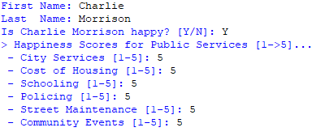

Fill out the information as required. As mentioned above, within the purpose section, it is required to enter a score from 1 through to 5 for the final 6 assessable criteria. This program will not allow any non-numbers, decimal points, or numbers outside of the range 1 🡪 5.

### Step 3

The program will have returned to the menu, and any other option can be selected. It will now be noticeable that the menu is slightly different from the original menu. The asterisk (*) on the right-hand side of the menu represents that the program is currently holding unsaved data. It will prompt you to save the data prior to quitting.

## Showing Records

### Step 1

From the menu screen, type in the letter “R” representing the “Show Records” menu item. This will show all records.

### Step 2

The menu will be displayed again at the bottom. It may not be noticeable at first that above the menu lie all the records.

## Changing File

### Step 1

From the menu screen, type in the letter “C” representing the “Change File” menu item. The program will confirm whether you would like to save the data prior to changing the file.

### Step 2

The program will appear as if it has just been opened from after the saving confirmation. The instruction on opening a new file is the exact same as when first opening the program.

### Step 3

The program will now create the file if required. As seen in the image above, the file next to the change file menu item is now my-town-2.csv, as we have requested.

## Saving Records

### Step 1

If the asterisk is appearing on the right of the menu, is it representing that the file is currently in an unsaved state, and an unexpected closure of the program will lose all unsaved data.

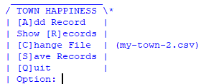

### Step 2

To prevent any data loss, it is recommended to regularly save the records as required. From the main menu type in “S” in order to select the menu item “Save Records”. This will save all data and remove the asterisk from the menu until any further changes have been made

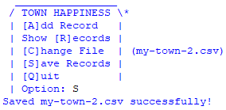

## 

## Quitting

### Step 1

To quit the program, enter “Q” into the menu; this represents “Quit”. If the file is unsaved (has an asterisk *), it will first request whether you want to save the data in the file.

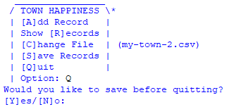

Enter “Y” to save the program and close it, enter “N” to disregard saving the program. This will delete all changes which have been made since the most previous save.